（1）If the threads are user-level threads

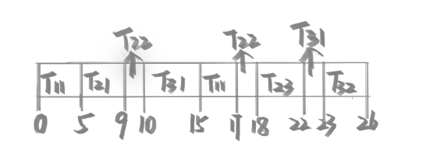

|  |  |  |
| --- | --- | --- |
| 进程 | **Tw** | **Ttr** |
| P1 | 10 | 17 |
| P2 | 12 | 18 |
| P3 | 17 | 26 |
| 平均 | 13 | 20.33 |

(2) If the threads are kernel (OS) supported threads.

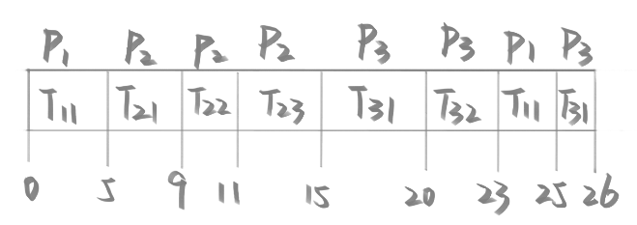

|  |  |  |
| --- | --- | --- |
| 进程 | **Tw** | **Ttr** |
| P1 | 18 | 25 |
| P2 | 5 | 15 |
| P3 | 17 | 26 |
| 平均 | 13.33 | 22 |